Full Stack Development with MERN
Final Report format
BookNest – Where Stories Nestle
(MERN Stack Online Book Store)
Introduction
🔹 Project Title: BookNest – Where Stories Nestle
🔹 Team Members:
Name | Role
Team Leader | Full Stack Developer (Frontend + Backend)
Team Member 2 | UI/UX Designer
Team Member 3 | Backend Developer
Team Member 4 | Database & Deployment Engineer

Project Overview
🔹 Purpose:
BookNest is a full-stack MERN application designed to provide a secure, user-friendly online platform for browsing, searching, and purchasing books. The goal is to create a modern, scalable bookstore with smooth navigation and secure authentication.
🔹 Key Features:
- User Registration & Login (JWT Authentication)
- Browse 100+ Books with images
- Search books by title or author
- Add to Cart functionality
- Place Orders
- View Order History
- Cloud Deployment (Render + Vercel)
- Secure MongoDB Atlas database

Architecture
🔹 Frontend (React.js – Vite)
- Component-based architecture
- Pages: Home, Register, Login, Books, Cart, Orders
- Axios used for API calls
- Protected routes for authentication
- Hosted on Vercel
🔹 Backend (Node.js + Express.js)
- RESTful API structure
- JWT authentication
- Middleware for validation
- CORS configured for production
- Hosted on Render
🔹 Database (MongoDB Atlas)
Collections:
- Users
- Books
- Orders
Database Interactions:
- Mongoose models
- CRUD operations
- Cloud-hosted NoSQL database

Setup Instructions
🔹 Prerequisites
- Node.js (v18+)
- MongoDB Atlas account
- Git
- npm

🔹 Installation
Step 1: Clone Repository
git clone https://github.com/Kushulatha-k/BookNest.git
cd booknest

Step 2: Backend Setup
cd backend
npm install
Create .env file:
PORT=5000
MONGO_URI=your_mongodb_connection_string
JWT_SECRET=your_secret_key
Run backend:
npm run dev

Step 3: Frontend Setup
cd frontend
npm install
npm run dev

Folder Structure
🔹 Client (Frontend)
frontend/
├── src/
│ ├── components/
│ ├── pages/
│ ├── api/
│ ├── App.jsx
│ └── main.jsx
├── package.json

🔹 Server (Backend)
backend/
├── models/
├── routes/
├── config/
├── server.js
├── package.json
└── .env

Running the Application
🔹 Frontend
cd frontend
npm run dev
Runs at:
http://localhost:5173
🔹 Backend
cd backend
npm run dev
Runs at:
http://localhost:5000

API Documentation
🔹 User Routes
Method | Endpoint | Description
POST | /api/users/register | Register new user
POST | /api/users/login | Login user
Example Request:
{
"email": "user@gmail.com",
"password": "123456"
}

🔹 Book Routes
Method | Endpoint | Description
GET | /api/books | Get all books
GET | /api/books/seed | Seed books

🔹 Order Routes
Method | Endpoint | Description
POST | /api/orders | Place order
GET | /api/orders/myorders | Get user orders

Authentication
- JWT-based authentication
- Token stored in localStorage
- Protected routes
- Password encrypted using bcrypt
- Middleware validates token before accessing protected APIs

User Interface
The UI includes:
- Animated backgrounds
- Responsive design
- Card-based book layout
- Navigation bar
- Styled cart and order pages
(Screenshots included in README)

Testing
Testing Strategy:
- API Testing using Postman
- Manual Integration Testing
- Authentication Testing
- Deployment Testing
All modules tested before production deployment.

Screenshots / Demo
🔗 Live Demo:
Frontend: https://book-nest-six-topaz.vercel.app/
Backend : https://booknest-backend-0buw.onrender.com
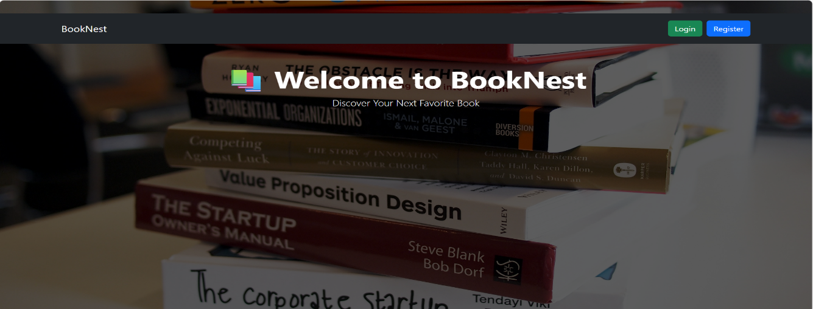


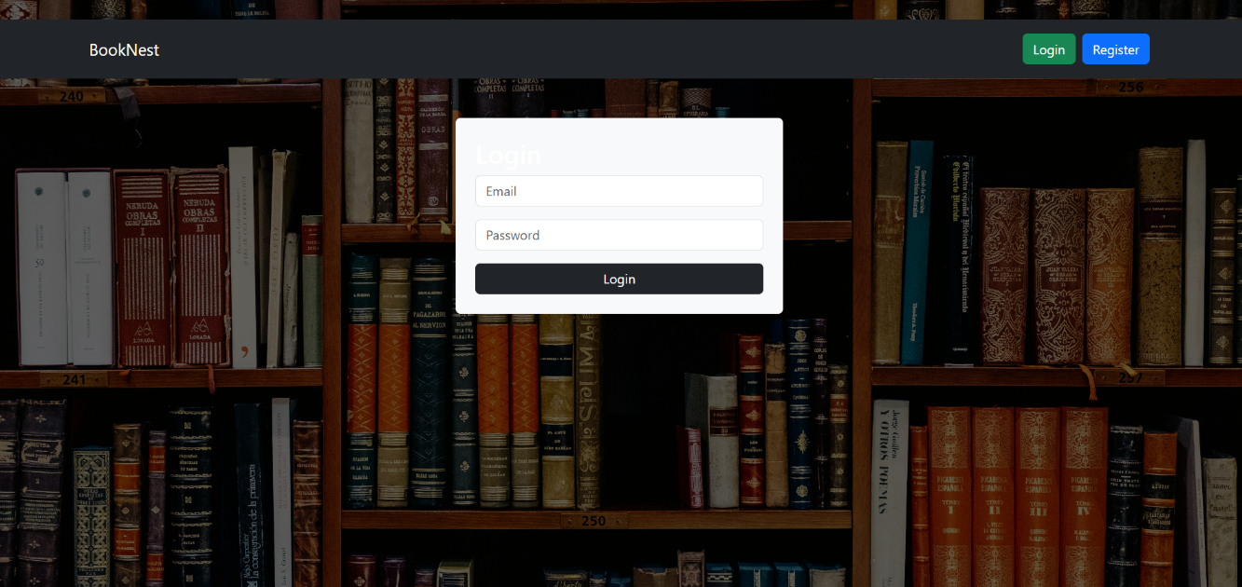

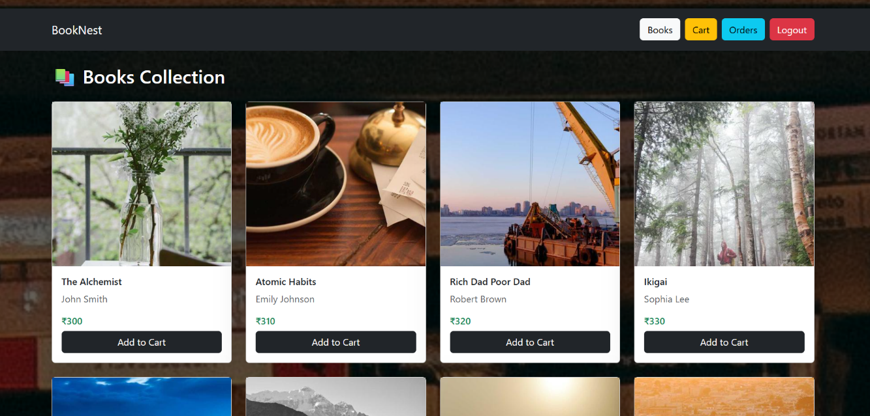

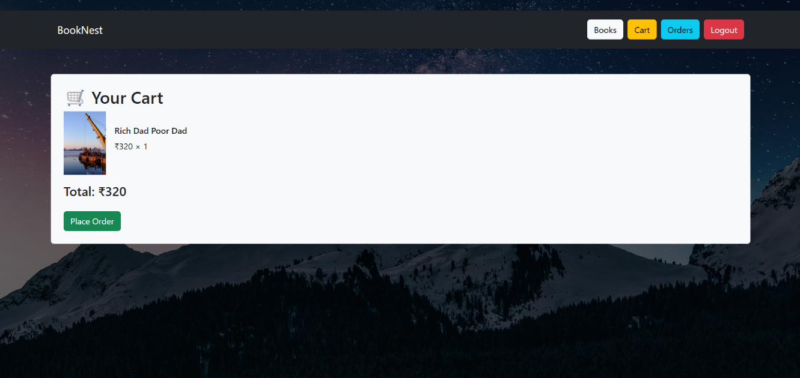
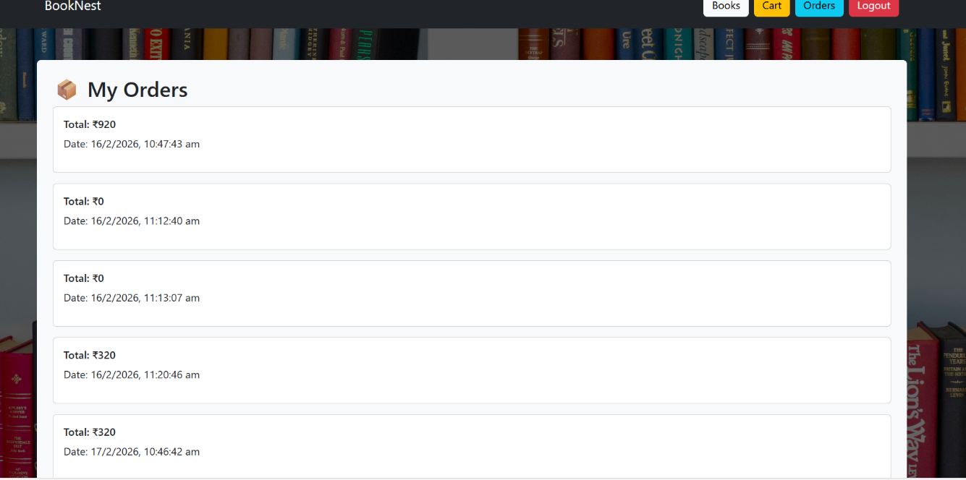

Known Issues
- No payment gateway integration (currently demo order placement)
- No email verification
- Limited admin dashboard features
- Basic search (no AI recommendation yet)
Future Enhancements
- Payment Gateway Integration (Stripe/Razorpay)
- AI-based Book Recommendation System
- Admin Dashboard
- Order Tracking
- Mobile Application (React Native)
- Wishlist Feature
- Review & Rating System
Conclusion : BookNest is a scalable MERN stack application that provides a secure, modern online bookstore platform. It demonstrates full-stack development, cloud deployment, authentication, and REST API integration using modern web technologies.
APPENDIX:
Source Code(if any):
import Navbar from "../components/Navbar";
import PageWrapper from "../components/PageWrapper";

function Home() {
return (
<PageWrapper bg="https://images.unsplash.com/photo-1512820790803-83ca734da794">
<Navbar />

<div className="container text-center mt-5">
<h1 className="display-4 fw-bold">📚 Welcome to BookNest</h1>
<p className="lead">Discover Your Next Favorite Book</p>
</div>
</PageWrapper>
);
}

export default Home;

import { useState } from "react";
import axios from "../api/axios";
import { useNavigate } from "react-router-dom";
import Navbar from "../components/Navbar";
import PageWrapper from "../components/PageWrapper";

function Register() {
const [form, setForm] = useState({
name: "",
email: "",
password: ""
});

const navigate = useNavigate();

const submitHandler = async (e) => {
e.preventDefault();

try {
await axios.post("/users/register", form);
alert("Registered Successfully ✅");
navigate("/login");
} catch (error) {
alert("Registration Failed ❌");
console.log(error.response?.data);
}
};

return (
<PageWrapper bg="https://images.unsplash.com/photo-1495446815901-a7297e633e8d">
<Navbar />

<div className="container mt-5 bg-light p-4 rounded" style={{ maxWidth: "400px" }}>
<h2>Register</h2>

<form onSubmit={submitHandler}>
<input
className="form-control mb-3"
placeholder="Name"
value={form.name}
onChange={(e) =>
setForm({ ...form, name: e.target.value })
}
/>

<input
className="form-control mb-3"
placeholder="Email"
value={form.email}
onChange={(e) =>
setForm({ ...form, email: e.target.value })
}
/>

<input
type="password"
className="form-control mb-3"
placeholder="Password"
value={form.password}
onChange={(e) =>
setForm({ ...form, password: e.target.value })
}
/>

<button className="btn btn-dark w-100">
Register
</button>
</form>
</div>
</PageWrapper>
);
}

export default Register;

import { useEffect, useState } from "react";
import axios from "../api/axios";
import Navbar from "../components/Navbar";
import BookCard from "../components/BookCard";
import PageWrapper from "../components/PageWrapper";

function Books() {
const [books, setBooks] = useState([]);

useEffect(() => {
const fetchBooks = async () => {
const { data } = await axios.get("/books");
setBooks(data);
};
fetchBooks();
}, []);

return (
<PageWrapper bg="https://images.unsplash.com/photo-1507842217343-583bb7270b66">
<Navbar />

<div className="container mt-4">
<h2 className="mb-4">📚 Books Collection</h2>

<div className="row">
{books.map((book) => (
<div className="col-md-3 mb-4" key={book._id}>
<BookCard book={book} />
</div>
))}
</div>
</div>
</PageWrapper>
);
}

export default Books;

import { useState, useEffect } from "react";
import Navbar from "../components/Navbar";
import axios from "../api/axios";
import { useNavigate } from "react-router-dom";
import PageWrapper from "../components/PageWrapper";

function Cart() {

const [cart, setCart] = useState([]);
const navigate = useNavigate();

useEffect(() => {
setCart(JSON.parse(localStorage.getItem("cart")) || []);
}, []);

const totalPrice = cart.reduce(
(acc, item) => acc + item.price * item.quantity,
0
);

const placeOrder = async () => {
const token = localStorage.getItem("token");

if (!token) {
alert("Please Login First");
navigate("/login");
return;
}

try {
await axios.post(
"/orders",
{
books: cart.map(item => ({
book: item._id,
quantity: item.quantity
})),
totalPrice
},
{
headers: { Authorization: token }
}
);

alert("Order Placed Successfully 🎉");

localStorage.removeItem("cart");
setCart([]);

navigate("/orders");

} catch (error) {
alert("Order Failed ❌");
}
};

return (
<PageWrapper bg="https://images.unsplash.com/photo-1519681393784-d120267933ba">
<Navbar />

<div className="container mt-5 text-dark bg-light p-4 rounded">
<h2>🛒 Your Cart</h2>

{cart.length === 0 && <p>Your cart is empty.</p>}

{cart.map(item => (
<div
key={item._id}
className="d-flex align-items-center mb-3"
>
<img
src={item.image}
alt={item.title}
width="80"
className="me-3"
/>

<div>
<h6>{item.title}</h6>
<p>
₹{item.price} × {item.quantity}
</p>
</div>
</div>
))}

{cart.length > 0 && (
<>
<h4>Total: ₹{totalPrice}</h4>

<button
className="btn btn-success mt-3"
onClick={placeOrder}
>
Place Order
</button>
</>
)}
</div>
</PageWrapper>
);
}

export default Cart;

import { useEffect, useState } from "react";
import axios from "../api/axios";
import Navbar from "../components/Navbar";
import PageWrapper from "../components/PageWrapper";

function Orders() {

const [orders, setOrders] = useState([]);

useEffect(() => {
const fetchOrders = async () => {
const token = localStorage.getItem("token");

if (!token) return;

try {
const { data } = await axios.get("/orders", {
headers: { Authorization: token }
});

setOrders(data);

} catch (error) {
console.log(error);
}
};

fetchOrders();
}, []);

return (
<PageWrapper bg="https://images.unsplash.com/photo-1524578271613-d550eacf6090">
<Navbar />

<div className="container mt-5 text-dark bg-light p-4 rounded">
<h2>📦 My Orders</h2>

{orders.length === 0 && <p>No Orders Yet.</p>}

{orders.map(order => (
<div
key={order._id}
className="card p-3 mb-3"
>
<h6>Total: ₹{order.totalPrice}</h6>
<p>
Date: {new Date(order.createdAt).toLocaleString()}
</p>
</div>
))}
</div>
</PageWrapper>
);
}

export default Orders;

GitHub : https://github.com/vamsi746/BookNest.git

Project Demo Link :
https://drive.google.com/file/d/11Keyg1mScVl3XNe7mr8SzXEGlfJz96od/view?usp=sharing

